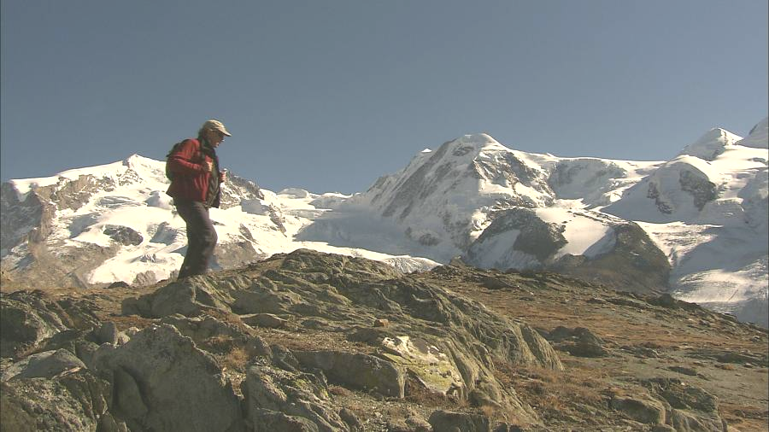

PRESS KIT

Richard Bangs’ Adventures with Purpose
“Switzerland: Quest for the Sublime”

A dynamic, new American Public Television special
that shows viewers how they can make a difference

1/60 in HD & NTSC Letterboxed

Beautifully photographed and edited in HDTV

Programming that celebrates heroes of the earth

Award-winning specials that encourages adventure and eco travel

From Small World Productions, KCTS/Seattle, & Richard Bangs’ Productions

Richard Bangs’ Adventures with Purpose
Switzerland: Quest for the Sublime
PRESS KIT

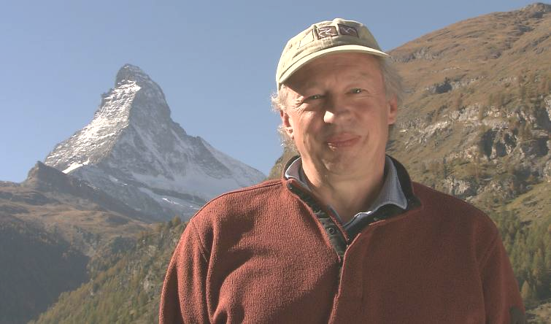
- Fact Sheet and Press Release

- Bios for Richard Bangs & Small World Productions

- Pittsburg Post-Gazette and NY Times profiles of Richard

- CD-ROM with MS Word files of press kit and photos

- Switzerland: Quest for the Sublime DVD

Program Description:

Adventures with Purpose—Switzerland: Quest for the Sublime follows modern explorer Richard Bangs on a quest to discover the roots of adventure travel and to search for what philosophers and poets of earlier times called “the sublime.” According to Bangs, “It’s no longer enough to just tick another destination off the list. Some travelers are looking for greater adventure and a deeper connection with the world around them. They’re looking for adventures with purpose.” Bangs’ purpose this time takes him to the scenic splendor of Switzerland. He begins in Lucerne with stops at Mt. Pilatus and nearby Entlebuch Valley, travels to St. Moritz, and boards the famous Glacier Express train. Bangs side-trips to the Jungfrau region, and finally lands in Zermatt to experience the rapture of a deadly mountain that helped change our perception of nature—the Matterhorn. Richard Bangs is often called the father of modern adventure travel.

Recent Awards:

A New York Times article by Richard has been honored with a 2007 Lowell Thomas Award for travel journalism.

Richard was honored last October with the 2007 Mark Dubois Award, a lifetime achievement award from Friends of the River that recognizes Richard’s contributions to worldwide river and wilderness conservation.


A previous Adventures with Purpose special, “Egypt: Quest for the Lord of the Nile” has been honored with two 2007 Silver Telly Awards; one in the documentary category and one in the travel and tourism category. According to the Telly Awards, "Tellys are the premier award honoring outstanding local, regional, and cable TV programs, as well as the finest video and film productions. The Telly Awards annually showcases the best work of the most respected advertising agencies, production companies, television stations, cable operator, and corporate video departments in the world. About 7% of the 13,000 entries each year are ‘Winners’ and receive the Silver Telly, our highest award." Recent Telly winners include: Columbia Pictures, Discovery Communications, Harpo Productions, Miramax Films, MSNBC, NASA, NBC, Reader's Digest, and Time Life.

